**Day 2 Lab Assignments**

1. Create New folder in the app folder (Name it: Models), and create the following inside it:
   1. Class Store, has properties:
      1. Name
      2. Array of branches
      3. Logo
   2. Interface named IProduct, which has:
      1. ID – of type number.
      2. Name – of type string
      3. Quantity – Of type number.
      4. Price – of type number.
      5. Img – of type string
      6. CateogryID – of type Number
   3. Interface Named ICategory, which has: ID, Name.
2. In the product component:
   1. In the Component class, add the following properties:
      * 1. Propery “ClientName” of type string.
        2. Property “ProductList” which is an array of IProduct, and in in constructor initialize it and add some products in different categories.
   2. In the constructor initialize the previous properties with any suitable values.
   3. In the Component HTML:
      * 1. <img> ta g to display store logo (Use property binding [src]).
        2. <h3> tag to display this text: “We offer an explicit discount of:” + Discount value from the discount property (Use angular Expression {{}}). **[Bonus]**
           1. If the value of discount is: “No discount”,
           2. hide this <h3> tag (Use structural directive *ngIf). **[Bonus]**
        3. Make a button “Buy”, that when clicked hides the Logo, and shows div “Thanks for purchasing from our Store” + ClientName Entered. (use Event binding (click), and IsPurshased flag, and method to toggle flag value, with *ngIf, to show or hide them).

Use *ngIf on the both parts that you want to show or hide.

1. Complete the following in the Products component:
   1. Disable button buy when the products with Quantity =0
   2. Change the background color to yellow for the rows which contains product with quantity=1 and make the background color with the default color when the quantity is more than 1 [Use ngClass or ngStyle].
   3. Add buy button with each product, which will decrease the available quantity of the product by 1 each time it clicked and test the rows color change as mentioned above.
   4. Make switch case on product quantity (last one item ,last two item,out of stock ,in stock).

3.Make “Product Card” custom attribute directive that makes a rounded border with box shadow around the div displaying products, as the following:

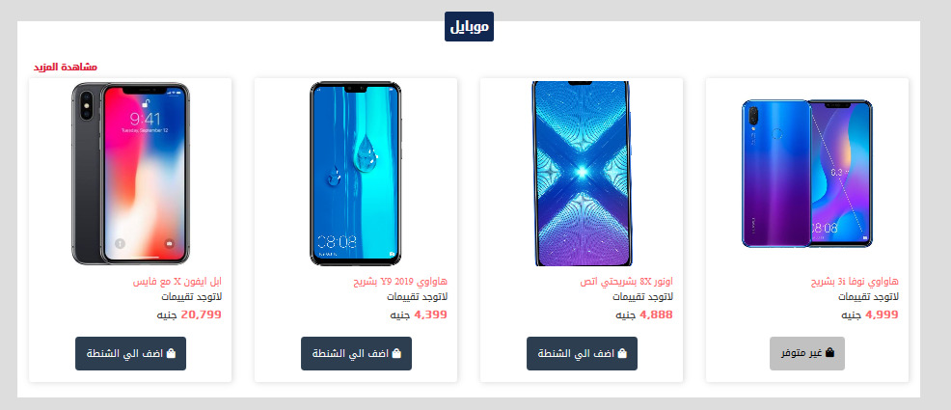

* 1. Use @HostListner to handle that on hover increases the x`, and on mouse out back to the original shadow.